Press Release

Absolute encoders with EtherNet/IP for maximized system uptime

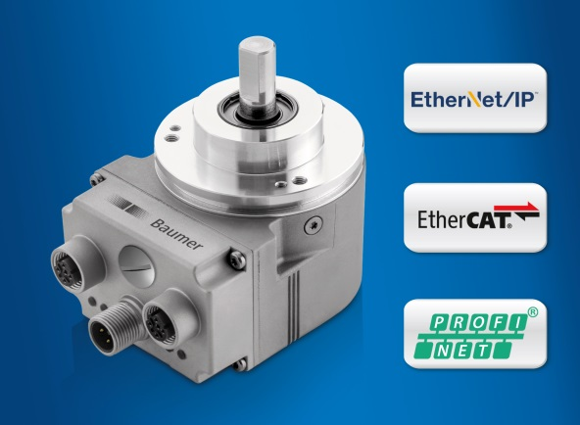
(06/08/2018) With PROFINET, EtherCAT and EtherNet/IP,
the EAL580 absolute encoders by Baumer offer the largest selection of real-time Ethernet interfaces. In plant and mechanical engineering, EAL580 encoders not only stand out by latest communication stacks but also by their extremely space-saving and short design with merely 47 mm installation depth and radial connection technology.

Numerous encoder features simplify integration and setup in the application. The IP address can be directly assigned at the encoder itself by rotary encoding switches. The preset/reset button enables convenient setting of specific position parameters, e.g. for referencing, while parameter plausibility checks with detailed status messages provide helpful on-site information. The multicolor LED activity indicator visualizes the current device status. EAL580 ensures maximum machine and system uptime thanks to Device Level Ring (DLR) protocol for continued consistent data transmission from encoder to controller even in the event of branch interrupts in the ring topology.

Presently, EAL580 is the most compact 58 mm Ethernet encoder in through-hollow shaft design. This allows it to be optimally integrated into machine or drive trains and will ease building redundant systems. The radial cable outlet eliminates connection cables with narrow bending radii prone to interference and the need for expensive angled connectors.
The field-proven, all-optical OptoTurn® technology for single and multiturn position detection guarantees maximum accuracy and immunity against magnetic fields. Thanks to the integrated web server, the encoder is ready to meet the requirements of the Industrial Internet of Things. Data diagnostics in the information of position, speed, temperature or operating hours allows for process optimization and improved machine and system layout.

Whether it comes to a completely new system development or just a redesign – OptoTurn® EAL580 is always the perfect match. Available with every standard real-time Ethernet interface, these encoders ensure easy implementation and maximum system uptime.

Further information: www.baumer.com/EAL580

Photo: The extremely compact Ethernet absolute encoders are ideal in quick and precise positioning operations.

Number of characters (with spaces): approx. 2098
Text and picture download at: www.baumer.com/press

Baumer Group
The Baumer Group is one of the worldwide leading manufacturers of sensors, encoders, measuring instruments and components for automated image processing. Baumer combines innovative technologies and customer-oriented service into intelligent solutions for factory and process automation and offers an unrivalled wide technology and product portfolio. With around 2,700 employees and 38 subsidiaries in 19 countries, the family-owned group of companies is always close to the customer. Baumer provides clients in most diverse industries with vital benefits and measurable added value by worldwide consistent high quality standards and outstanding innovative potential. Learn more at www.baumer.com on the internet.

Press contact:  Petra Reichle  Marketing Communications Manager  Phone +49 (0)7720 942 264  Fax +49 (0)7720 942 955  preichle@baumer.com  www.baumer.com | Company contact global:  Baumer Group  Phone +41 (0)52 728 11 22  Fax +41 (0)52 728 11 44  sales@baumer.com  www.baumer.com

