Press Release

Inductive position detection in tight spaces
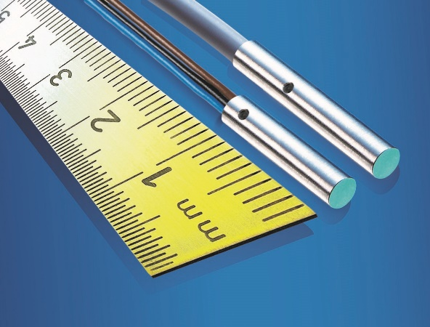
(16.08.2017) In machine tool spindles, miniature grippers, or robotics, space runs out in a hurry. Every integrator knows the pain of trying to get cable runs to work in the system, without compromising the sensor performance. With its new IFRM 03 Short inductive proximity sensor series, Baumer offers powerful solutions for even the tightest spaces. These sensors have a diameter of only 3 mm and allow positioning and object recognition in places where there is almost no space behind the sensor.
Two versions are available: a 16 mm short sensor with cable connection, and a 12 mm short version with litz wire connection. In contrast with their predecessors, the new sensors offer a 25% larger sensing distance despite their shorter length. When dealing with miniature sensors that have to be mounted very close to the target object, every millimeter counts. That extra 25% means significantly improved protection against collisions with the moving measured object and consequently increased process safety. Our thorough factory calibration program ensures extremely low standard deviation and easy installation of the sensors. In serial production, individual adjustment can be dispensed with in many applications. The sensors are very strong for their size. Thanks to a temperature compensation function optimized for the typical applications of 10 to 60°C, the sensors show a particularly low drift. This guarantees a constant sensing distance as well as maximum repeat accuracy.
The litz wire option offers an interesting alternative for very tight spaces (e.g., motor spindles). Sensors with a cable outlet need at least 1 to 2 cm for cable routing, in addition to the housing length. With the litz wire connection, the sensors allow a much smaller bending radius thanks to their thin cross-section. This reduces the effective space required by a further 30% compared to cable connection versions of the same length, making them ideal for short distances.
Robust, maintenance-free and durable - inductive proximity sensors by Baumer
As an inductive sensor pioneer, Baumer offers a broad portfolio of robust, maintenance-free and extremely durable rectangular and cylindrical inductive sensors with integrated electronics. Due their very high repeat accuracy and switching frequency, as well as temperature stability and excellent EMC properties, they offer maximum process safety in any environment.
Further information: www.baumer.com

Fig.: The new subminiature short inductive IFRM 03 by Baumer

Number of characters (with spaces): approx. 2.486
Text and picture download at: www.baumer.com/press

Baumer Group
The Baumer Group is one of the worldwide leading manufacturers of sensors, encoders, measuring instruments and components for automated image processing. Baumer combines innovative technologies and customer-oriented service into intelligent solutions for factory and process automation and offers an unrivalled wide technology and product portfolio. With around 2,400 employees and 38 subsidiaries in 19 countries, the family-owned group of companies is always close to the customer. Baumer provides clients in most diverse industries with vital benefits and measurable added value by worldwide consistent high quality standards and outstanding innovative potential. Learn more at www.baumer.com on the internet.

Press contact:  Andrea Memminger-Wäsch  Baumer Group  Phone +41 (0)52 728 11 22  Fax +41 (0)52 728 11 44  amemminger-waesch@baumer.com  www.baumer.com | Company contact global:  Baumer Group  Phone +41 (0)52 728 11 22  Fax +41 (0)52 728 11 44  sales@baumer.com  www.baumer.com

