Press Release
Anuga FoodTec: Baumer presents smart sensor solutions in Cologne

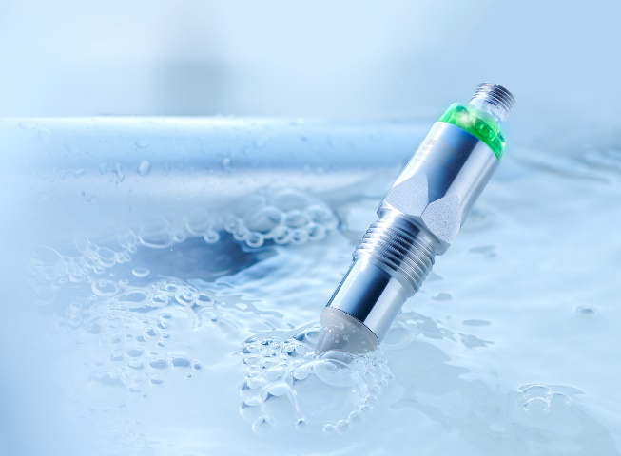
(25.03.2022) Heat-resistant process sensors for CIP applications, perfect timing for container exchange in warehousing, smart engineering from food processing to packaging: sensor expert Baumer is going to present clever solutions for the food and beverage industry at Anuga FoodTec in Cologne (April 26 to 29, 2022). Among other things, Baumer will be premiering a world's first - a sensor to save resources, to enhance food safety and to prevent production downtime thanks to the innovative measuring principle. The PAD20 (see picture) reliably reports empty state of transport containers and hence defines the perfect point in time for container exchange, for example in yogurt production. The principle is simple, the technology behind is smart: The sensor detects even the smallest air and gas bubbles in the process medium and this way prevents dry running of pumps and plant downtime. In parallel, it allows for containers being emptied completely. This will increase plant efficiency and cut down on product loss at highest process safety and quality.
Saving energy and media in CIP applications
How do manufacturers reduce costs in CIP applications? For example with high-precision, durable sensors. New PAC50 process sensor from Baumer reliably measures conductivity even at 140 degrees Celsius. Thanks to the compact design and streamlined sensor tip, the robust sensor reduces flow resistance in the line which makes it the product to choose for small production lines in the food and beverage industry. Similar to other Baumer sensors, PAC50 features IO-Link as standard. This allows for collecting secondary data such as temperature for process monitoring and communication to the controller. The Dual Channel feature allows users to operate PAC50 via analog or digital channel or even both in parallel. This way, with the PAC50 Baumer offers maximum flexibility and high security of investment.
Flexible solutions for packaging machines
The time pressure imposed on machine and plant manufacturers in the packaging industry is enormous. Here, Baumer scores high as a one-stop supplier for the packaging industry. Because, Baumer sensor solutions provide maximum flexibility. It all starts with smart sensors. Just an example: Thanks to the high functional reserve capacity, optical sensors reliably detect changing demanding surfaces - whether reflective, transparent, matte or uneven. To plant manufacturers, this means that one and the same Baumer sensor can be deployed for different application requirements and packaging materials. This cuts down on production complexity and simplifies servicing.
Learn more at: www.baumer.com/l/foodtech-meetup-2022
Baumer at Anuga FoodTec: Hall 7.1 Booth A038 B039

Image: Baumer sensors, here the new PAD20, provide precise measurement data for the beverage and food industry. As a one-stop supplier for manufacturing and packaging Baumer offers the maximum flexibility.

Total characters (with spaces) approx. 2250
Text with illustration available for download at:www.baumer.com/press

Baumer Group
The Baumer Group is one of the worldwide leading manufacturers of sensors, rotary encoders, measuring instruments, and components for automated image processing. Baumer combines innovative technologies and customer-oriented service into intelligent solutions for factory and process automation to offer an unrivalled wide technology and product portfolio. With around 2700 employees and 39 branches in 19 countries, the family-owned company is always close to the customer. Baumer provides clients in the most diverse industries with vital benefits and measurable added value by worldwide consistently high quality standards and outstanding innovation potential. For more information, visit www.baumer.com.

Press contact:  Public Relations  Baumer Group  press@baumer.com  www.baumer.com | Business contact Germany/Austria:  Baumer GmbH  Phone +49 (0)6031 60 07 0  Fax +49 (0)6031 60 07 60 70  sales.de@baumer.com  www.baumer.com | Business contact Switzerland:  Baumer Electric AG  Phone +41 (0)52 728 11 22  Fax +41 (0)52 728 11 44  sales.ch@baumer.com www.baumer.com

