Press Release

Ultrasonic miniature sensors with patented coating for level measurement with aggressive media
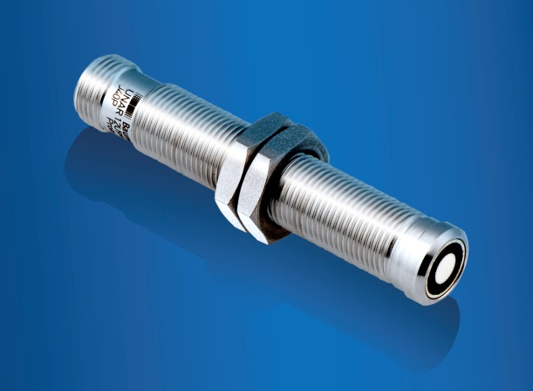
(03122018) Aggressive media such as vapors or cleaning agents are at times a challenge for standard ultrasonic sensors. The sensor face, called a transducer, can be worn by these media and thus become impaired. The new chemically robust UNAR / URAR 12 miniature sensors are a great fit for these environments thanks to an ultra-thin patented parylene coating on the sensor face and stainless steel all-metal housing. These compact sensors are an addition to the preexisting Baumer portfolio of chemically robust sensors and are available as proximity, retro-reflective and distance sensors. Some example applications are level measurement of paints and varnishes in the printing industry or in pressure tanks or compact laboratory containers in the pharmaceutical industry. Thanks to very short response times of < 6 ms, a narrow sound beam and the FDA-compliant material, they are also suitable for fast applications such as presence detection of bottles in fillers in the food and beverage industry. In contrast to ultrasonic sensors with metal caps, the parylene-coated sensors can be mounted very easily and with no additional aids.
Insert press photo here
Further information: www.baumer.com/ultrasonic

Fig.: Chemically-robust stainless steel ultrasonic sensor with patented parylene face coating

Number of characters (with spaces): approx. 1.279
Text and picture download at: www.baumer.com/press

Baumer Group
The Baumer Group is one of the worldwide leading manufacturers of sensors, encoders, measuring instruments and components for automated image processing. Baumer combines innovative technologies and customer-oriented service into intelligent solutions for factory and process automation and offers an unrivalled wide technology and product portfolio. With around 2,600 employees and 38 subsidiaries in 19 countries, the family-owned group of companies is always close to the customer. Baumer provides clients in most diverse industries with vital benefits and measurable added value by worldwide consistent high quality standards and outstanding innovative potential. Learn more at www.baumer.com on the internet.

Press contact:  Andrea Memminger-Wäsch  Baumer Group  Phone +41 (0)52 728 11 22  Fax +41 (0)52 728 11 44  amemminger-waesch@baumer.com  www.baumer.com | Company contact global:  Baumer Group  Phone +41 (0)52 728 11 22  Fax +41 (0)52 728 11 44  sales@baumer.com  www.baumer.com

