Press Release

Inductive marine sensors for onshore and offshore systems

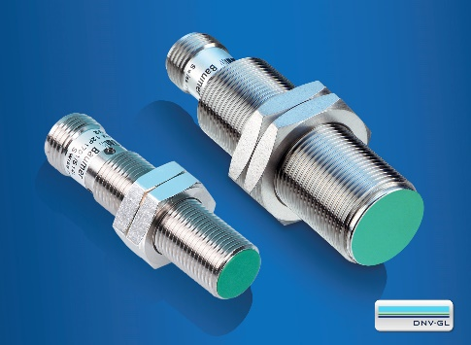
(31/10/2018) Inductive marine sensors by Baumer were specifically developed for use in harsh environments. In order to minimize the planning work involved in the development phase for onshore and offshore system manufacturers, these sensors already have the required DNVGL-CG-0339 certification for marine applications. This simplifies sensor selection and significantly reduces the effort required for testing and approval to meet M.E.D. requirements (Marine Equipment Directive 96/98/EC).
Thanks to their increased resistance to salt air, salt water, high vibrations and EMC, the inductive proximity switches are highly durable and meet the strictest requirements in the field of maritime equipment, such as harbor cranes, wind power plants or marine propulsion systems. To meet these requirements and to guarantee high fail-safe characteristics, the marine sensors are equipped with an integrated diagnostic function. This allows cable ruptures to be detected quickly and reliably, and the sensor function to be monitored without the need to invest in additional, complementary counter inputs for rotational speed measurements.
The inductive marine sensors by Baumer are available in corrosion-resistant metal housings in M12 and M18 sizes, with a sensing distance of up to 10 mm, a switching frequency of up to 1 kHz and an operating range from -40 to +75 °C.
Further information: www.baumer.com/sturdy-inductive

Photo: Baumer inductive marine sensors with DNVGL certification

Number of characters (with spaces): approx. 1420
Text and picture download at: www.baumer.com/press

Baumer Group
The Baumer Group is one of the worldwide leading manufacturers of sensors, encoders, measuring instruments and components for automated image processing. Baumer combines innovative technologies and customer-oriented service into intelligent solutions for factory and process automation and offers an unrivalled wide technology and product portfolio. With around 2,700 employees and 38 subsidiaries in 19 countries, the family-owned group of companies is always close to the customer. Baumer provides clients in most diverse industries with vital benefits and measurable added value by worldwide consistent high quality standards and outstanding innovative potential. Learn more at www.baumer.com on the internet.

Press contact:  Christina Frick  Baumer Group  Phone +49 7771 6474 1205  Fax +41 (0)52 728 11 44  cfrick@baumer.com  www.baumer.com | Company contact global:  Baumer Group  Phone +41 (0)52 728 11 22  Fax +41 (0)52 728 11 44  sales@baumer.com  www.baumer.com

