Press Release

Detection or positioning on all metals, with an accuracy of within one micron: Factor 1 inductive sensors by Baumer

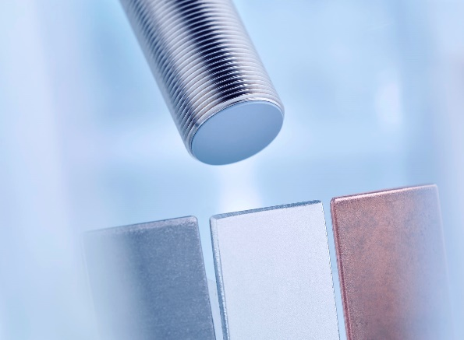
(05/23/2019) Inductive sensors very often form the basis for the reliable control of machines and systems.
In applications where non-ferrous metals such as aluminum need to be detected at the same working distance as steel, Factor 1 inductive sensors are a perfect fit. Baumer offers a unique selection of such sensors in switching and measuring versions. The contactless proximity switches operate with a switching frequency of up to 3 kHz. Inductive distance sensors with an analog output signal, enable the positioning of an object within one micron accuracy as well as the detection of imbalance, wear, deformation or material expansion.
Factor 1 senses at a consistently high range of eight millimeters for the measuring version and as much as ten millimeters for the switching version – regardless of whether the object to be detected is ferromagnetic structural steel, stainless steel or aluminum. This is practical and simplifies the design when parts made of different metals need to be processed on the same system. Even when only one material is to be processed, especially with non-ferrous metals or non-ferromagnetic metals, a Factor 1 sensor is a reliable choice. While the measuring or switching distance is reduced by up to 70 percent with conventional sensors, Factor 1 sensors with their larger measuring range can be mounted further away, reducing the risk of damage.
In the popular M18 size, Baumer offers a Factor 1 sensor with an analog output which provides a voltage of 0 to 10 volts, depending on the measured distance. This enables the sensor to detect imbalances in rotating parts or deviations in the material thickness of metal parts, up to a distance of 8 mm. No other inductive sensor on the market offers this precision in conjunction with the advantages of Factor 1 technology. Thanks to the comprehensive adjustment options through the teach input, the user can adapt the output curve to his requirements, for example by defining a rising or falling curve.
Baumer offers Factor 1 sensors in sizes from 6.5 mm to M18, with a maximum switching distance of 10 mm. The measuring version with a measuring range of 8 mm is currently available in size M18.
Further information:
www.baumer.com/c/13506
www.baumer.com/c/13451

Photo: Inductive proximity switches and distance sensors without reduction factor on different metals.

Number of characters (with spaces): approx. 2300
Text and picture download at: www.baumer.com/press

Baumer Group
The Baumer Group is one of the worldwide leading manufacturers of sensors, encoders, measuring instruments and components for automated image processing. Baumer combines innovative technologies and customer-oriented service into intelligent solutions for factory and process automation and offers an unrivalled wide technology and product portfolio. With around 2,700 employees and 38 subsidiaries in 19 countries, the family-owned group of companies is always close to the customer. Baumer provides clients in most diverse industries with vital benefits and measurable added value by worldwide consistent high quality standards and outstanding innovative potential. Learn more at www.baumer.com on the internet.

Press contact:  Christina Frick  Baumer Group  Phone +49 7771 6474 1205  Fax +41 (0)52 728 11 44  cfrick@baumer.com  www.baumer.com | Company contact global:  Baumer Group  Phone +41 (0)52 728 11 22  Fax +41 (0)52 728 11 44  sales@baumer.com  www.baumer.com

