Press Release
Despite the chip crisis: Baumer resumes delivery of industrial cameras

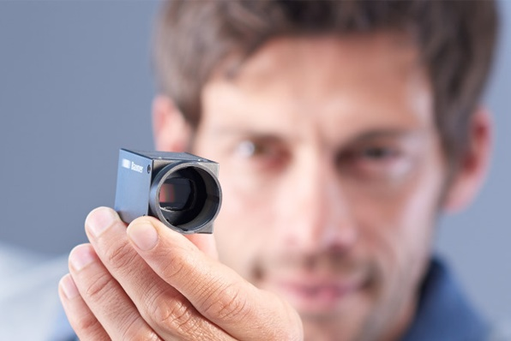
(8/31/2022) Right in the midst of the chip crisis, Baumer provides a silver lining behind the clouds over the tense vision market. In August, the expert in industrial cameras and components for automated image processing managed to resume deliveries of USB cameras. After more than a year of supply bottleneck and sharp price increase, this is surely good news to many customers of industrial cameras. When the supply problems caused by FPGA shortage came up, Baumer tried to continue customer supplies under any circumstances. Well-stocked warehouses and a highly motivated team allowed to bridge shortages for a few months.
After the redesign: USB cameras available again
Right at the beginning of the supply problems, Baumer started a camera redesign initiative to replace the FPGAs no longer available by integrated circuits. Baumer now presents a first success to customers. The first 11 models of the versatile cameras with USB interface have been available again since August 2022. This way, a major part of the camera portfolio will be available again soon with standard lead times, all functionalities and in the renown Baumer quality.
Jochen Braun, sales manager Vision products, is confident that both redesigns and the prompt Baumer reaction will provide present and potential customers with a welcome respite. "Finally, we are in a position to support our business partners again, not only with consult but also with products, so that together we will master the chip crisis," says Braun. "VISION in Stuttgart is certainly a good opportunity to meet and talk things over. We expect the high-resolution GigE cameras to be available again in volume quantities by the end of December 2022."
Further information: www.baumer.com/c/14047
Baumer at VISION in Stuttgart, Germany: Hall 8, Booth 8D40

Image: After a redesign, Baumer has resumed delivery of USB cameras like the VCXU in standard lead times. Image: Baumer

Total characters (with spaces) approx. 1700
Text and with illustration available for download at: www.baumer.com/press

Baumer Group
The Baumer Group is one of the world's leading experts for high-performant sensors and sensor technology in industrial automation. The unrivalled broad product portfolio, precise measured values, and smart sensor functionalities provide intelligent solutions for digitalized production. With around 2,800 employees and 39 of its own development centers, production sites, and sales units in 19 countries, the Swiss family-owned Group is always close to the customers. As an innovation leader for 70 years, Baumer has been creating decisive market advantages and measurable added value with consistently high quality standards. Further information: www.baumer.com

Press contact:  Holger Thissen  Public Relations Manager  Baumer Group  Phone +41 (0)52 728 17 12  hthissen@baumer.com  www.baumer.com | Business contact Germany/Austria:  Baumer GmbH  Phone +49 (0)6031 60 07 0  Fax +49 (0)6031 60 07 60 70  sales.de@baumer.com  www.baumer.com | Business contact Switzerland:  Baumer Electric AG  Phone +41 (0)52 728 11 22  Fax +41 (0)52 728 11 44  sales.ch@baumer.com www.baumer.com

