Press Release

Precise and convenient - Baumer miniature sensor with integrated beam path in 3D CAD data reduces design-in effort

(12/09/2020) Thanks to their high precision and reliability, the optical O200 miniature sensors ensure maximum process safety in factory automation. However, they offer even more advantages: They significantly reduce the effort of designers during design-in. With the O200 miniature sensors, Baumer is the only supplier that provide its customers with 3D CAD data with an integrated beam path, which solves an old problem. If a designer wants to integrate a sensor into a machine or system, he or she has to determine exactly how it has to be aligned and mounted to avoid collisions and interfering reflections. Until now, designers have therefore had to laboriously and time-consumingly reconstruct the sensor beam path from data sheets. This is a great effort for many users - especially for those who integrate many sensors with different sizes and functional principles. In the O200 miniature sensor product family, the beam path is now integrated in the CAD data. In addition, the light beam is aligned with the mounting holes, which enables easy and fast mounting without fine adjustment.
Insert press photo here
Reliability and convenience for design-in and planning
Beyond the Standard - offering more than the usual - this is the motto of the Swiss sensor manufacturer Baumer. For Markus Imbach, Senior Product Manager for Sensor Solutions at Baumer, this is not a marketing slogan. "With the O200 sensors, we offer our customers noticeable added value from the design stage through commissioning to ongoing operation." As a result, the sensors with LED and laser light source not only offer extraordinary detection reliability even with strong ambient light or reflections, so that no further mechanical protective measures are required.
They are also the first sensors whose 3D CAD data include the beam path. Thanks to this information, designers can immediately use the beam geometry and range of the respective functional principle (diffuse sensor with background suppression, SmartReflect®, retro-reflective or through-beam sensor) with different light sources (red-light LED, Baumer PinPoint LED, or laser), as well as the respective focusing (convergent, divergent, or parallel) for planning the assembly without having to design it themselves from the manufacturer's specifications. In order to ensure that there are no sources of interference in the area of the beam path, designers can display additional beam paths for the O200 sensors to cover possible production lot variation. This variation is only 2 percent for the O200 sensors, but even such a small deviation can be relevant. In this way, Baumer succeeds in combining safety with convenience.
In addition, the beam path is referenced to the mounting holes (qTarget®), which makes fine adjustment unnecessary. The light beam is thus aligned with constant accuracy over the entire sensor series. As a result, collisions and interfering reflections can be avoided from the start.
Maximum flexibility for every application
The extensive O200 portfolio offers the right miniature sensor for every detection task, with or without a reflector. They even detect ultra-black, shiny surfaces, transparent or small objects, and narrow gaps. Thanks to their high functional reserves and extreme ambient light immunity, they minimize the risk of machine downtimes due to false detections and thus ensure maximum process safety. As a result of their standardized design and the uniform mounting hole spacing with stainless steel mounting sleeves or M3 threaded bushes, the O200 sensors offer a high degree of mounting compatibility and thus great freedom with regard to the installation position.
The compact design and the variant diversity also increase the flexibility in machine design. The CAD data with integrated beam path reduce the design-in effort, and constructive measures against ambient light influences are not necessary. In short: The O200 miniature sensors redefine reliability, precision, and flexibility.
Further information: www.baumer.com/O200

Photo: Baumer combines safety with comfort for the design-in thanks to 3D CAD data with integrated beam path
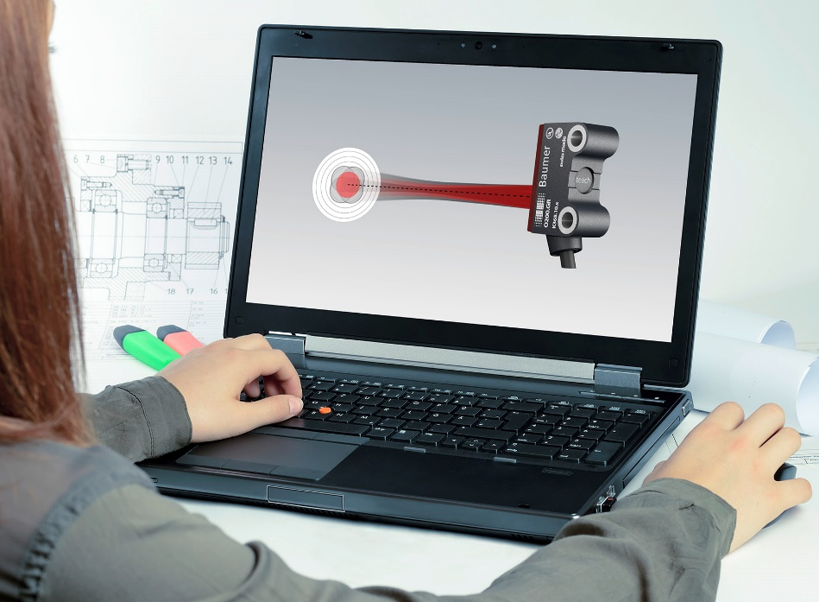
Number of characters (with spaces): approx. 4199
Text and picture download at: www.baumer.com/press

Baumer Group
The Baumer Group is one of the worldwide leading manufacturers of sensors, encoders, measuring instruments and components for automated image processing. Baumer combines innovative technologies and customer-oriented service into intelligent solutions for factory and process automation and offers an unrivalled wide technology and product portfolio. With around 2,700 employees and 39 subsidiaries in 19 countries, the family-owned group of companies is always close to the customer. Baumer provides clients in most diverse industries with vital benefits and measurable added value by worldwide consistent high quality standards and outstanding innovative potential. Learn more at www.baumer.com on the internet.

Press contact:  Andrea Memminger-Wäsch  Baumer Group  Phone +41 (0)52 728 11 22  Fax +41 (0)52 728 11 44  amemminger-waesch@baumer.com  www.baumer.com | Company contact global:  Baumer Group  Phone +41 (0)52 728 11 22  Fax +41 (0)52 728 11 44  sales@baumer.com  www.baumer.com

