Press Release

Direct control: 65 MP cameras for Canon EF lenses

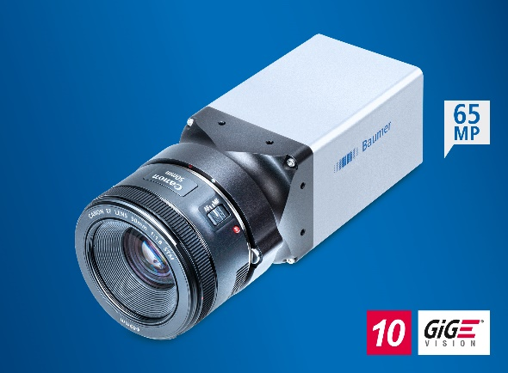
(06/01/2021) Two new 65 megapixel cameras enhance the Baumer portfolio of high-resolution and robust 10 GigE cameras of the LX series. Thanks to an integrated EF mount, Canon EF lenses are easily configured via Baumer GAPI, Baumer neoAPI, or third party software to allow the focus and the aperture to be dynamically matched to the applications. External accessories and associated cabling become completely unnecessary. This simplifies the integration and reduces costs while enhancing reliability. Dynamic lens control mainly benefits applications with varying operating distances and lighting situations, e.g., track-and-trace in pharmaceutical logistics. The serial production of the new models will commence in the 2nd quarter of 2021.
The high-quality Canon EF lenses deliver high-contrast images with great depth of field. The cameras also support modern lenses with ultrasound motors. These combine reduced power consumption with precise, low-noise, and very quick focus with high reliability for the cost-efficient and robust implementation of applications. Based on the GMAX3265 sensor from Gpixel, the cameras offer excellent image quality and a high dynamic range of 66 dB. A compact optical format with a diagonal of 37 mm is achieved by a small pixel size of only 3.2 µm. This reduces edge shadowing and simplifies the choice of lenses. Minimal exposure times of 19 µs reduce the motion artifacts of fast moving objects. Thanks to the 65 megapixel resolution, the number of required cameras for each application is often even cut in half to reduce system and integration costs as well as enhance reliability.
The 10 GigE cameras of the LX series are the ideal choice for demanding inspection tasks that place strict demands on both the image capture precision and throughput. They have an exceptionally high range of functions for solving demanding applications. These include Multi ROI, shading correction, HDR, precise time synchronization according to IEEE 1588, or the direct control of illumination without external controllers. Robust M12 plug connectors, IP 65 and IP 67 protection class, as well as a temperature range from -30 °C to 60 °C make the cameras especially well-suited for difficult ambient conditions, such as the analysis of motion sequences in outdoor sports or the inspection of overhead lines and pantographs in railway transportation. In addition, thanks to their 10 GigE interface they can be easily and inexpensively integrated, while the images can be efficiently transmitted with a high bandwidth of 1.1 GB/s, reducing the evaluation time.
More information about the LXT cameras: https://www.baumer.com/cameras/LXT

Photo: The new 65 MP cameras with integrated EF mount allow the dynamic adjustment of focus and aperture with varying working distances or illumination conditions.

Number of characters (with spaces): approx. 2700
Text and picture download at: www.baumer.com/press

Baumer Group
The Baumer Group is one of the worldwide leading manufacturers of sensors, encoders, measuring instruments and components for automated image processing. Baumer combines innovative technologies and customer-oriented service into intelligent solutions for factory and process automation and offers an unrivalled wide technology and product portfolio. With around 2,700 employees and 39 subsidiaries in 19 countries, the family-owned group of companies is always close to the customer. Baumer provides clients in most diverse industries with vital benefits and measurable added value by worldwide consistent high quality standards and outstanding innovative potential. Learn more at www.baumer.com on the internet.

Press contact:  Nicole Marofsky  Marketing Communication  Baumer Group  Phone +49 (0)3528 43 86 19  Fax +49 (0)3528 43 86 86  nmarofsky@baumer.com  www.baumer.com | Company contact global:  Baumer Group  Phone +41 (0)52 728 11 22  Fax +41 (0)52 728 11 44  sales@baumer.com  www.baumer.com

