Press Release

For the reliable detection of the minutest details: robust 10 GigE cameras with 24 MP Sony Pregius S and 65 MP Gpixel sensors
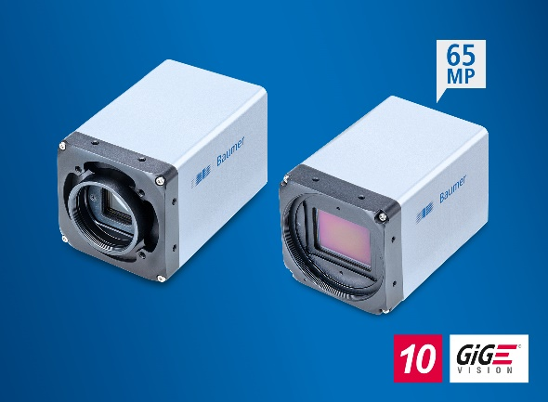
(10/15/2020) Baumer is expanding its 10 GigE cameras of the LX series with four new models that perfectly support applications with very high resolution and image quality demands for the reliable detection of even the minutest details and deviations. At the same time, they have a very high frame rate for increased throughput. Equipped with Sony Pregius S sensors, the cameras provide 50 frames/s at 24 megapixels. The Gpixel models offer an even higher resolution of 65 megapixel at 18 frames/s. This benefits primarily applications such as the inspection of printed circuit boards, displays, or semiconductors, as well as 3D measurement technology and track & trace. At the same time, applications in demanding ambient conditions outdoors such as in sports or rail transport are also ideally supported thanks to the robust design and extensive range of functions. The serial production of the new cameras will commence this year.
The models with a Sony Pregius S IMX530 sensor have a backside illumination pixel architecture that offers reduced shading effects and excellent image quality for stable evaluations. The limited pixel size of only 2.74 µm enables a very compact optical format of 4/3’’. This way, existing systems can be equipped with considerably higher resolution without having to change the visual setup. Thanks to the C mount, a large variety of inexpensive standard lenses is available for every type of application. Should an even better image quality be required, the use of TLF mount lenses is also flexibly possible.
The GMAX3265 sensor from Gpixel used for the 65 megapixel models is distinguished by excellent image quality and high dynamic range of 66 dB. The small pixel size of 3.2 µm results in a compact visual format with a diagonal length of 37 mm. This facilitates the choice of lenses based on the M58 mount and reduces peripheral shading. Thanks to the minimal exposure time of 19 µs, motion artifacts can be reduced even with high object velocities. Due to the very high resolution, often only half the usual number of cameras is required for each application. This reduces system and integration costs while enhancing reliability.
The new LX models have an exceptionally high range of functions for solving demanding applications. These include Multi ROI, shading correction, HDR, precise time synchronization according to IEEE 1588, or the direct control of illumination. Robust M12 plug connectors, protection class IP 65 and IP 67, as well as a temperature range from -30 °C to 60 °C make the cameras especially well-suited for difficult ambient conditions. In addition, thanks to their 10 GigE interface they can be easily and cost-effectively integrated, while the images can be efficiently transmitted with a high bandwidth of 1.1 GB/s, reducing the evaluation time.
Learn more at: https://www.baumer.com/cameras/LXT
Photo: The new 10 GigE LX models with 24 MP Sony Pregius S or 65 MP Gpixel sensors are the ideal choice for demanding inspection tasks that place strict demands on both the image capture precision and the throughput.

Number of characters (with spaces): approx. 3000
Text and picture download at: www.baumer.com/press

Baumer Group
The Baumer Group is one of the worldwide leading manufacturers of sensors, encoders, measuring instruments and components for automated image processing. Baumer combines innovative technologies and customer-oriented service into intelligent solutions for factory and process automation and offers an unrivalled wide technology and product portfolio. With around 2,700 employees and 39 subsidiaries in 19 countries, the family-owned group of companies is always close to the customer. Baumer provides clients in most diverse industries with vital benefits and measurable added value by worldwide consistent high quality standards and outstanding innovative potential. Learn more at www.baumer.com on the internet.

Press contact:  Nicole Marofsky  Marketing Communication  Vision Competence Center  Phone +49 (0)3528 43 86 19  Fax +49 (0)3528 43 86 86  nmarofsky@baumer.com  www.baumer.com | Company contact global:  Baumer Group  Phone +41 (0)52 728 11 22  Fax +41 (0)52 728 11 44  sales@baumer.com  www.baumer.com

