Press Release

Image processing over 10 kilometers: new LX cameras with fiber optics interface

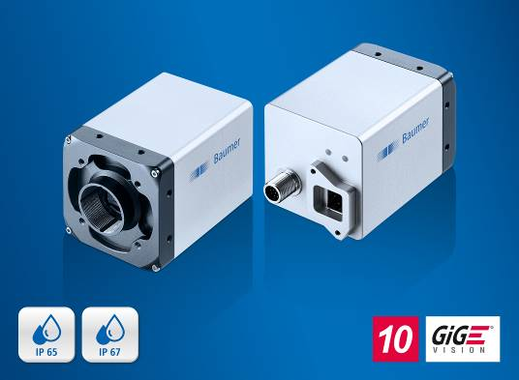
(04/25/2019) Five new models with a 10 GigE Vision compliant interface for use with optical cables expand the Baumer LX series. The cameras are ideal for applications requiring a high bandwidth of 1.1 GB/s over long distances. In accordance with the SFP+ module used, long-distance solutions can be achieved up to 10 kilometers – without the need for media converters. Together with the reasonably-priced cables, this saves system costs. At the same time, the system design becomes simplified and extremely flexible. The series production of the new models with a resolution of 3, 5, 9 and 12 megapixel begins in the 3th quarter of 2019.
Fiber optics technology has proven its worth in the IT and telecommunications field. It allows to break through the 100 m cable length limit of Gigabit Ethernet. Thereby, the system setup of large production facilities, transportation or motion analysis in sports can be simplified. A further advantage for industrial image processing is its insensitivity to electromagnetic interferences when used directly next to engines or other industrial devices. This can reduce the entire application’s sensitivity to interference. The cables are also extremely robust, flexible in terms of wiring and can be sharply bent, which means they can easily be integrated over long distances. Compared with the 10GBase-T transmission using copper cables, they have a lower power loss, which means that less waste heat is created and cooling measures can be reduced. By supporting IEEE 1588, the LX cameras also work in perfect synchronization in multi-camera systems.
The 10 GigE models in the LX series are the ideal choice for inspection tasks with demanding requirements on image detail accuracy and throughput. Their robust industrial design resists mechanical stress and ensures reliable, long-term image processing. Thanks to liquid lens support via RS232, they are also suitable for applications with varying working distance, such as in 2D code inspection on packages of different heights. The cameras have four opto-decoupled power outputs with pulse width modulation and an output power of up to 120 W (max. 48 V / 2.5 A) for direct illumination control without an external controller. With their optional patented tube system, the cameras offer IP 65 and IP 67 protection class without any external housing.
More information at: www.baumer.com/cameras/LX
Baumer at Control: Hall 3, Booth 3504

Photo: The new LX cameras with a 10 GigE Vision compliant fiber optics interface enable high data transfer of 1.1 GB/s in combination with cable lengths up to 10 kilometers.

Number of characters (with spaces): approx. 2400
Text and picture download at: www.baumer.com/press

Baumer Group
The Baumer Group is one of the worldwide leading manufacturers of sensors, encoders, measuring instruments and components for automated image processing. Baumer combines innovative technologies and customer-oriented service into intelligent solutions for factory and process automation and offers an unrivalled wide technology and product portfolio. With around 2,700 employees and 38 subsidiaries in 19 countries, the family-owned group of companies is always close to the customer. Baumer provides clients in most diverse industries with vital benefits and measurable added value by worldwide consistent high quality standards and outstanding innovative potential. Learn more at www.baumer.com on the internet.

Press contact:  Nicole Marofsky  Marketing Communication  Vision Competence Center  Phone +49 (0)3528 43 86 19  Fax +49 (0)3528 43 86 86  nmarofsky@baumer.com  www.baumer.com | Company contact global:  Baumer Group  Phone +41 (0)52 728 11 22  Fax +41 (0)52 728 11 44  sales@baumer.com  www.baumer.com

