Press Release

Baumer sensor for air and gas bubble detection increases process reliability
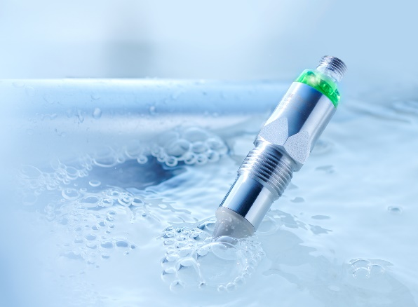
With the PAD20 sensor series, Baumer offers an innovative solution to a previously unsolved problem: the detection of air and gas bubbles in process media. Awarded the Dairy Technology Prize 2021 in the category Environment and Sustainability, the sensor detects even smallest air and gas inclusions and, among other things, thus prevents pumps from running dry and the entailed facility downtime. In numerous field-proven applications, this way the sensor has been increasing plant efficiency at maximum process reliability and quality.
Innovation for multi-faceted industrial and hygiene applications
Julian Budde, the Baumer product manager for process sensors, is convinced of the success of the sensor presented at drinktec in Munich, Germany: "Air and gas inclusions in process media lead to plant downtime, maintenance effort and reduced product quality. Such inclusions pose a major challenge to varied industries. The intelligent detection of such inclusions is a smart Baumer solution."
Thanks to its innovative operating principle, PAD20 is the product to choose for monitoring heating and cooling systems in mechanical plant engineering. Detecting air and gas bubbles that directly impair equipment performance and function, the sensor will increase system efficiency with process stabilization in parallel.
Originally, Baumer developed PAD20 for a customer in the F&B industry. This customer wanted to prevent his installations and pumps from running dry respectively empty during container exchange. At the same time, transport containers with fruit concentrate should be fully emptied to exploit the maximum of resources. A problem lacking any solution so far. PAD20 detects even smallest air and gas bubbles in the dosing operation of fruit concentrate and this way identifies the optimum time for container exchange.
Independent of the medium, the sensor will detect liquids with a dielectric constant higher than 1.5 and this way provides maximum flexibility. Two individually defined switching ranges allow users to optimally adjust the sensor to the process requirements.
According to Julian Budde, the smart PAD20 sensor principle offers users "high process and product quality across a wide application spectrum."
Further information: www.baumer.com/pad20
Baumer at drinktec: Hall 3, Booth A300

Photo: Baumer Sensor PAD20 for reliable air and gas bubble detection

Number of characters (with spaces): approx. 2300
Text and picture download at: www.baumer.com/press

Baumer Group
The Baumer Group is one of the world's leading experts for high-performant sensors and sensor technology in industrial automation. The unrivalled broad product portfolio, precise measured values, and smart sensor functionalities provide intelligent solutions for digitalized production. With around 2,800 employees and 39 of its own development centers, production sites, and sales units in 19 countries, the Swiss family-owned Group is always close to the customers. As an innovation leader for 70 years, Baumer has been creating decisive market advantages and measurable added value with consistently high quality standards. Learn more about Baumer: www.baumer.com

Press contact:  Marketing  Baumer Group  press@baumer.com  www.baumer.com | Company contact global:  Baumer Group  Phone +41 (0)52 728 11 22  Fax +41 (0)52 728 11 44  sales@baumer.com  www.baumer.com

