Press Release

Conductivity measurement where space is tight: New Baumer PAC50 sensor scores with high performance and compactness

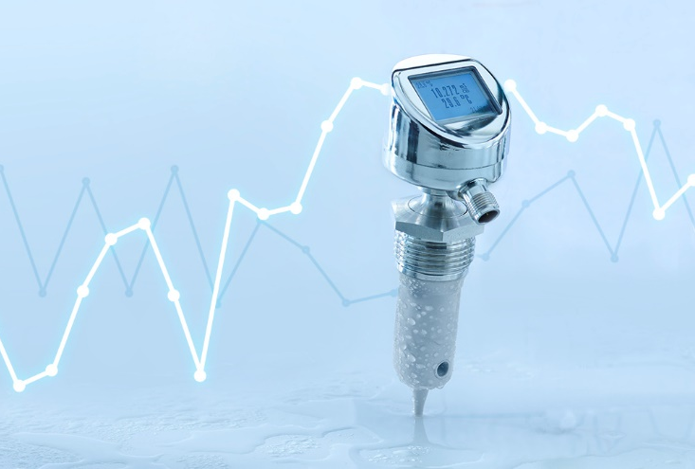
Measuring conductivity in the smallest space: The new Baumer PAC50 process sensor sets new standards and is perfect for small-sized production installations. The new product development from the Swiss sensor company scores with high performance tightly packed in a very compact design. Thus, the sensor is ideal for use in small production facilities – in general industrial applications but especially in the food and pharmaceutical industries. Its high temperature stability up to 140° Celsius allows for permanent and reliable use even in SIP systems.
The little brother of proven AFI sensor
The measuring performance and durability of the Baumer AFI4/5 conductivity sensors have been convincing users for many years, especially manufacturers of food and pharmaceutical products. Here, the sensor plays to its strength in CIP (Cleaning in Place) and SIP (Sterilization in Place) applications. Nevertheless, customers kept on asking for an even more compact variant which not necessarily had to provide all features of the CombiLyz series. Baumer now offers the little brother of the proven AFI4/5 series, a powerful sensor that easily integrates into tight production lines. Since here often a single millimeter counts. To realize the required level of compactness, when developing PAC50 the Baumer engineers went to the limits of what is physically possible. And they succeeded. The sensor housing measures a mere 60 millimeters. "We were even able to cut the display size of the new sensor down to 32x25 millimeters," reports Martin Leupold, Product Manager Process Sensors at Baumer.
PAC50: Robust and durable
Further to the compact design, PAC50 stands out by its robustness and durability. Thanks to the sensor tip in one-piece design it better withstands strong and frequent temperature fluctuations than sensors do with a two-piece tip. PAC50 delivers reliable performance even at temperatures of up to 140 degrees Celsius, "a value at which the wheat has long sorted from the chaff," says Leupold. Experience shows that many sensors on the market already come to their limits at 100 degrees Celsius. And thanks to the sensor tip made entirely of high-performance plastic poly ether ether ketone (PEEK), it is also extremely resistant to chemicals. PAC50 in its H version is hence ideally suited for CIP. Another bonus point is the all-stainless steel sensor housing with all parts laser-welded. "Thanks to the manufacturing method, PAC50 is resistant to all ambient conditions outside the pipe and therefore very robust," confirms Leupold as an expert in process sensor technology.
PAC50 in its H version complies with the EHEDG (European Hygienic Equipment Design Group) hygiene standard applied to the food, beverage and pharmaceutical industries and is 3-A certified. All media-contacting parts are FDA certified.
Dual Channel: analog and digital interface in a single sensor
Like other Baumer sensors, IO-Link is a standard feature of PAC50. This allows for collecting secondary data such as temperature for process monitoring and communication to the controller. Via the IO-Link interface users can easily and quickly parameterize the sensor prior to and in operation - even when the sensor is integrated via an analog interface. The Dual Channel feature allows users to operate PAC50 via analog or digital channel or even both in parallel. "This way, with the PAC50 Baumer offers maximum flexibility and high security of investment," emphasizes Leupold.
Many features for optimal use
To optimally match different pipe cross-sections Baumer offers the PAC50 with three different sensor lengths: 37, 60 and 83 millimeters. Customers have the choice between the H and S sensor variant according to market requirements. The H variant features a sensor tip made of primarily produced PEEK (FDA certified). The S variant uses recycled PEEK granulate and this way Baumer supports companies aiming on more sustainable production. The sensor can be ordered with or without display. The display enables convenient sensor settings via touch operation and flexible colors of backlighting provide information on the process status. The PAC50 has been available as of March 2022 and can be directly ordered at www.baumer.com.
Baumer at drinktec: Hall A3, Booth 300

Number of characters (with spaces): approx. 4300
Text and picture download at: www.baumer.com/press

Photo: Measuring conductivity in the smallest space: The new Baumer PAC50 process sensor sets new
standards and is perfect for small-sized production installations.

Baumer Group
The Baumer Group is one of the world's leading experts for high-performant sensors and sensor technology in industrial automation. The unrivalled broad product portfolio, precise measured values, and smart sensor functionalities provide intelligent solutions for digitalized production. With around 2,800 employees and 39 of its own development centers, production sites, and sales units in 19 countries, the Swiss family-owned Group is always close to the customers. As an innovation leader for 70 years, Baumer has been creating decisive market advantages and measurable added value with consistently high quality standards. Learn more about Baumer: www.baumer.com

Press contact:  Marketing  Baumer Group  press@baumer.com  www.baumer.com | Company contact global:  Baumer Group  Phone +41 (0)52 728 11 22  Fax +41 (0)52 728 11 44  sales@baumer.com  www.baumer.com

