Press Release

Baumer GAPI SDK for ARM® processors allows for simplified implementation of embedded vision applications
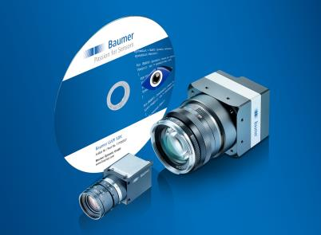
(06/06/2016) The newest SDK version of the Baumer GAPI for Linux® ARM® processors supports optimally harmonized software integration of Baumer GigE cameras in embedded vision applications. Accessing cost- and energy-efficient ARM®-based hardware platforms will reduce system cost. Existing applications can be easily ported to ARM®-based platforms to benefit from reduced development time and cost without requiring new developments.
Baumer GAPI supports for camera application-relevant hardware platforms of several manufacturers via two installation packages: standard and basic. The standard packages allow for the use of manufacturer-specific evaluation kits (presently NVIDIA® Jetson, Raspberry Pi®, CompuLab and ODROID) to quickly analyze the capabilities for embedding in the image processing solution. Basic packages enable user-specific developments aided by the hard and softfloat processors of the ARM® ARM7™ family for optimal application architecture in terms of performance, design and cost. All the required libraries and software components are already integrated. Furthermore, the SDK provides versatile functionalities for process-safe embedding into the image processing software to ensure a stable and reliable solution in the application. The efficient image processor ensures optimal color calculation for Raw Bayer image data and the action command allows for quick, hardware-near triggering. Supporting camera events and status information will be a valuable help for automated process control. Furthermore, consistent and standard-compliant implementation of GenICam™, GenTL and GigE Vision® ensures easy integration of all Baumer cameras with GigE or Dual GigE interface.
More information on Baumer GAPI SDK at: www.baumer.com/cameras/SDK

Photo: New GAPI SDK by Baumer for Linux® ARM®-based platforms is oriented towards the ever-growing presence of embedded vision applications.
Number of characters (with spaces): approx. 1800
Text and picture download at: www.baumer.com/press

Baumer Group
The Baumer Group is one of the worldwide leading manufacturers of sensors, encoders, measuring instruments and components for automated image-processing. Baumer combines innovative technologies and customer-oriented service into intelligent solutions for factory and process automation and offers an unrivalled wide technology and product portfolio. With around 2,300 employees and 38 subsidiaries in 19 countries, the family-owned group of companies is always close to the customer. Baumer provides clients in most diverse industries with vital benefits and measurable added value by worldwide consistent high quality standards and outstanding innovative potential. Learn more at www.baumer.com on the internet.

Press contact:  Nicole Marofsky  Marketing Communication  Vision Competence Center  Phone +49 (0)3528 43 86 19  Fax +49 (0)3528 43 86 86  nmarofsky@baumer.com  www.baumer.com | Company contact global:  Baumer Group  Phone +41 (0)52 728 11 22  Fax +41 (0)52 728 11 44  sales@baumer.com  www.baumer.com

