# Press Release

**Smart encoders: Cost-efficient connection and parameterization flexibility**

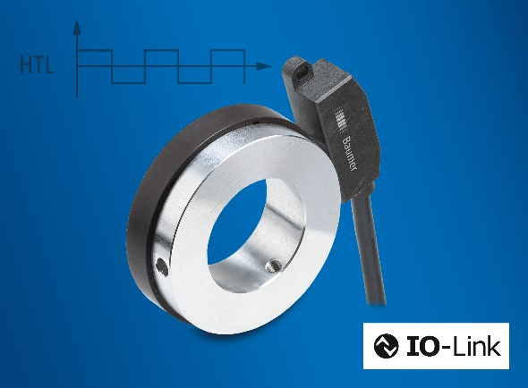(11/23/2021) Electrical and mechanical integration of encoders has become much easier and more economically viable. The new bearingless encoder EB200E from Baumer is proving this right. It can be compactly integrated on any axis without complex adaptation of the mechanics. EB200E is the first smart incremental bearingless encoder with IO-Link on the market. The interface reduces the cost and effort of cabling and a speed monitoring function replaces additional hardware components.

The IO-Link interface allows for up to 8 encoders to be connected to an IO-Link master by cost-effective standard cables. This way, EB200E opens up completely new areas of application: Encoder parameterization is via IO-Link. This interface enables parameterization of two switching outputs to act as a speed monitor for overspeed, speed range, standstill or direction of rotation. Furthermore, EB200E also delivers conventional HTL signals.

With a shallow installation depth of 12 mm and flexible shaft diameters, the bearingless encoder integrates into the machine design in a space-saving way. Thanks to non-contact sensing between sensor head and magnet ring, the encoder endures dirt, shock or vibration. Also the new Baumer Sensor Suite supports plant engineers as convenient PC tool for intuitive parameterization and data visualization.

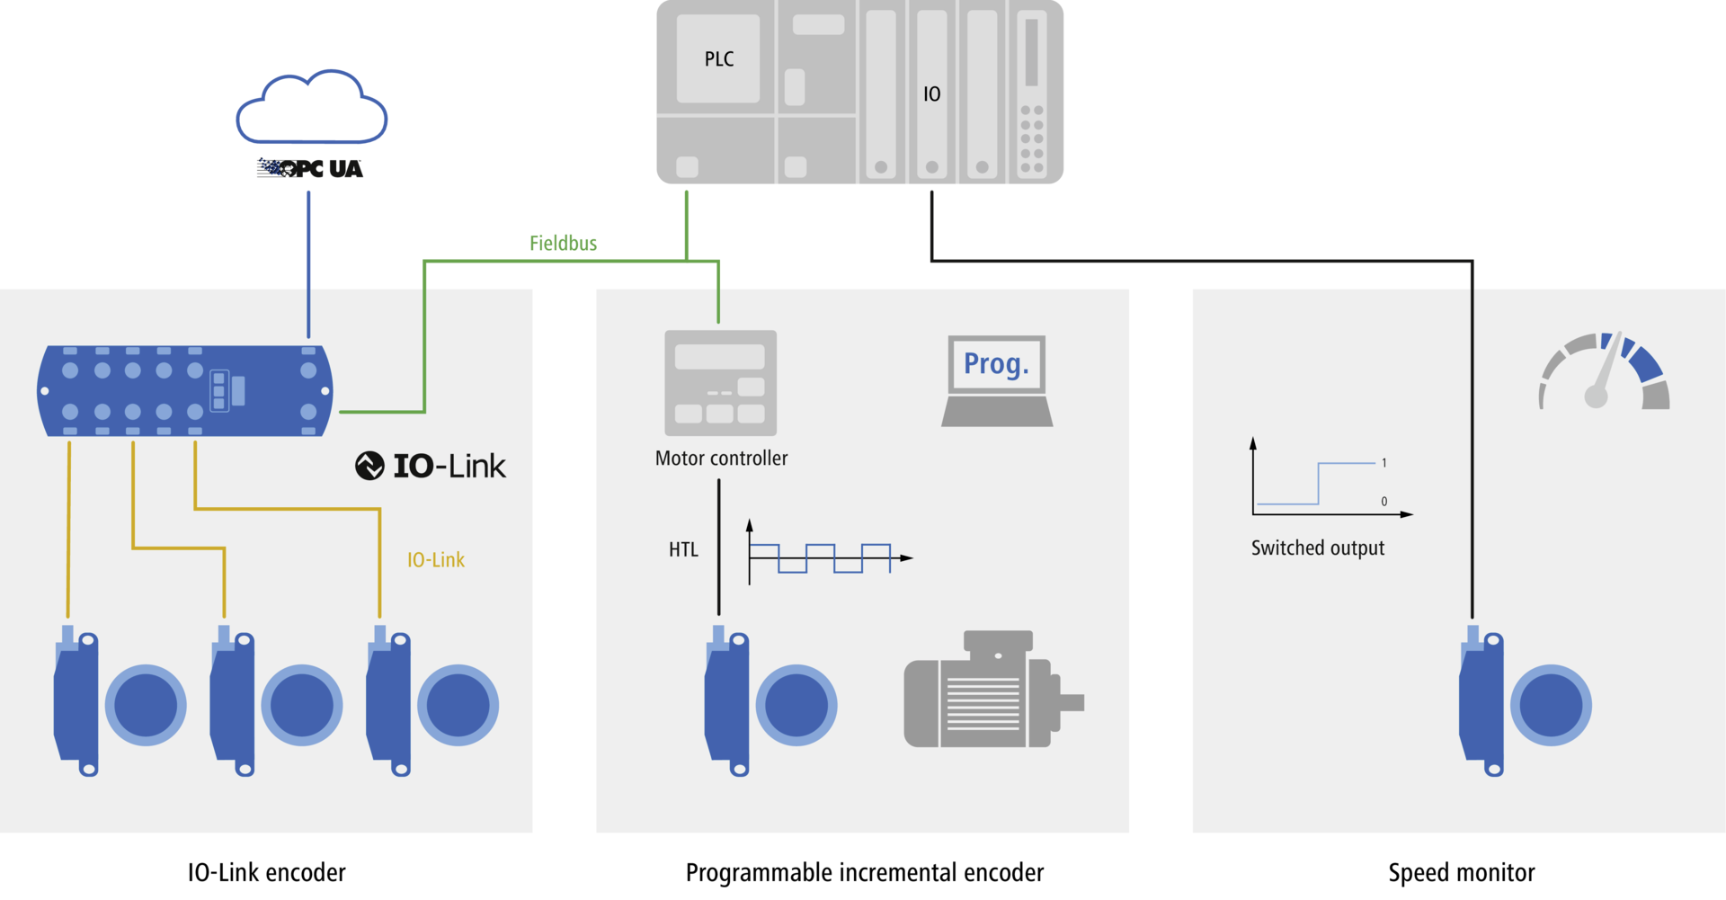

Learn more: [www.baumer.com/eb200e](http://www.baumer.com/eb200e)

**Baumer at SPS 2021: Hall 4A, Booth 335**

Photo: EB200E smart encoder allows for more efficient machine concepts based on cost-effective connection and parameterization flexibility.

Infographic: By virtue of speed and position feedback, speed monitoring function and IO-Link parameterization, EB200E integrates into future-proof machine environments.

Anzahl Zeichen (mit Leerzeichen): ca. 1511

Text und Bild Download unter: [**www.baumer.com/press**](http://www.baumer.com/press)

**Baumer Group**

Baumer gehört zu den führenden Spezialisten für Sensoren und Sensorlösungen für die Fabrik- und Prozessautomation. Die Messwerte und Informationen unserer Produkte ermöglichen unseren Kunden, ihre Geräte, Maschinen und Anlagen effizienter, produktiver, zuverlässiger und sicherer zu machen. Das Familienunternehmen ist mit rund 2700 Mitarbeitern und Produktionswerken, Vertriebsniederlassungen und Vertretungen in 39 Niederlassungen und 19 Ländern immer nahe beim Kunden. Mit weltweit gleichbleibend hohen Qualitätsstandards und einer grossen Innovationskraft verschafft Baumer seinen Kunden aus zahlreichen Branchen entscheidende Vorteile und messbaren Mehrwert. Weitere Informationen im Internet unter [www.baumer.com](http://www.baumer.com).

Number of characters (with spaces): approx. 1400

Text and picture download at: [**www.baumer.com/press**](http://www.baumer.com/press)

**Baumer Group**

The Baumer Group is one of the worldwide leading manufacturers of sensors, encoders, measuring instruments and components for automated image processing. Baumer combines innovative technologies and customer-oriented service into intelligent solutions for factory and process automation and offers an unrivalled wide technology and product portfolio. With around 2700 employees and 39 subsidiaries in 19 countries, the family-owned group of companies is always close to the customer. Baumer provides clients in most diverse industries with vital benefits and measurable added value by worldwide consistent high quality standards and outstanding innovative potential. Learn more at [www.baumer.com](http://www.baumer.com) on the internet.

|  |  |
| --- | --- |
| **Press contact:**  N.N.  Marketing  Baumer Group  press@baumer.com  [www.baumer.com](http://www.baumer.com/) | **Company contact global:**  Baumer Group  Phone +41 (0)52 728 11 22  Fax +41 (0)52 728 11 44  sales@baumer.com  [www.baumer.com](http://www.baumer.com) |