Press Release

Double down: 16 new VeriSens vision sensors increase productivity

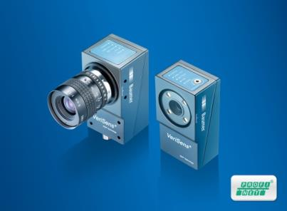
(11/07/2016) With the new VeriSens models 510, 700 and 800 of the XC, XF and ID series users benefit from doubled productivity in image-based quality inspection. Integrating Industrial Ethernet, these vision sensors feature the high level of connectivity required by the Internet of Things. Series production begins in December 2016.
16 new VeriSens models provide enhanced processing performance, cutting image processing time in half in many applications, in part location and in code and text reading. Productivity increases by twice the number of inspected objects. Alternatively, a single vision sensor can do twice the number of feature checks in the same time, enhancing inspection scope. Sophisticated code reading algorithms improve reading reliability under industrial conditions. The configurable web interface was expanded with the new VeriSens MultiViewer. It allows for viewing up to 16 VeriSens vision sensors simultaneously on one browser screen which can be adapted to the running process. This way, the operator keeps track of the entire installation. Integrated PROFINET ensures efficient interfacing in Industrial Internet, cutting down on integration and cabling effort while easing setup.
In all industries, VeriSens vision sensors are the solution for sophisticated inspection tasks by performing up to 32 feature checks at once: presence and completeness checks, inspecting object positions, reading and evaluating imprints as plain text (OCR/OCV) and matrix and bar codes including GS1 codes. Using VeriSens Application Suite, the configuration software unified across all series, vision sensor setup will take only a few minutes. Thanks to contour-based processing in real-time by the patented Baumer FEX image processor, stability in image evaluation is always ensured. Furthermore, the configurable web interface enables convenient re-configuration directly in the machine control browser.
More information on VeriSens vision sensors at: www.baumer.com/verisens
Baumer at VISION: Hall 1, booth F32

Photo: New VeriSens vision sensors integrating Industrial Ethernet double productivity.

Number of characters (with spaces): approx. 2000
Text and picture download at: www.baumer.com/press

Baumer Group
The Baumer Group is one of the worldwide leading manufacturers of sensors, encoders, measuring instruments and components for automated image-processing. Baumer combines innovative technologies and customer-oriented service into intelligent solutions for factory and process automation and offers an unrivalled wide technology and product portfolio. With around 2,300 employees and 38 subsidiaries in 19 countries, the family-owned group of companies is always close to the customer. Baumer provides clients in most diverse industries with vital benefits and measurable added value by worldwide consistent high quality standards and outstanding innovative potential. Learn more at www.baumer.com on the internet.

Press contact:  Nicole Marofsky  Marketing Communication  Vision Competence Center  Phone +49 (0)3528 43 86 19  Fax +49 (0)3528 43 86 86  nmarofsky@baumer.com  www.baumer.com | Company contact global:  Baumer Group  Phone +41 (0)52 728 11 22  Fax +41 (0)52 728 11 44  sales@baumer.com  www.baumer.com

