Press Release (international)

New production site in North Macedonia further strengthens the Baumer position in Europe
(10/31/2019)
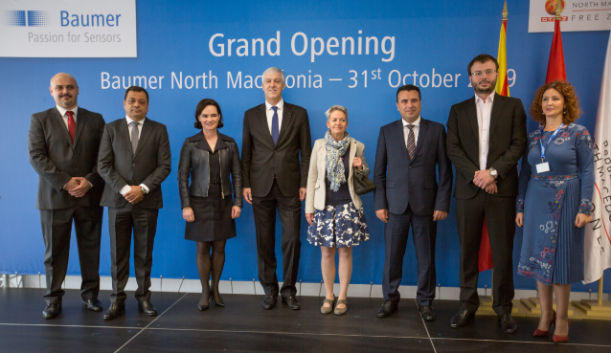
The search for qualified experts for future growth is a focal challenge all globally operating companies must face. Being well aware for some time already and taking the demographic change into account, the Swiss family-owned Group has dedicated itself to establish an ever more close-knit network of affiliated companies to strengthen the Baumer position in Europe and the world.
After thorough analysis and research, the free trade zone near Skopje in Northe Macedonia proved to offer ideal conditions. Being close to the universities in Skopje, highly qualified experts will be recruited nearby. The region’s good infrastructure and the international airport being near are further crucial location advantages. These are ideal preconditions to foster optimal cooperation and exchange between the new location and the Baumer headquarters in Switzerland to ensure prompt deliveries to the Baumer customers throughout Europe. In return, the new location offers excellent working conditions, a modern and air-conditioned building, clean and quiet workplaces, in-house canteen and great many career options.
The first construction phase on the 19,000 sqm site was to establish the building of around 4,000 sqm in total - with 2,500 sqm production space and 600 sqm entirely dedicated to development and administration. In addition, there is sufficient space left for future growth. It took only 18 months from deciding for Skopje in December 2017 and first sensor production in May 2019.
The grand opening ceremony in the new location was attended by representatives from government, the free trade zone and the Baumer management. The presence of the Prime Minister of North Macedonia, the Deputy Prime Minister in charge of economic affairs, the CEO of North Macedonia Free Zones Authority as well as representatives of the Embassy reflect the high significance attached by the region to the new Baumer location.

Photo: Baumer was proud to welcome the guests to the grand opening ceremony of the new production site in North Macedonia: Aleksandar Stevkovski - Plant Manager, PhD. Kocho Angjushev - Deputy Prime Minster for Economic Affairs of the Republic of North Macedonia, Kristiane Vietze - Secretary of the Supervisory Board of the Baumer Group, PhD. Oliver Vietze - CEO and owner Baumer Group, Ms. Sybille Suter Tejada - Ambassador of Switzerland in the Republic of North Macedonia, Zoran Zaev - Prime Minister of the Republic of North Macedonia, Aleksandar Mladenovski - CEO of North Macedonia Free Zones Authority, Sonja Stefanovska - HR Manager (from left to right)

Number of characters (with spaces): approx. 1.908
Text and picture download at: www.baumer.com/press

Baumer Group
The Baumer Group is one of the worldwide leading manufacturers of sensors, encoders, measuring instruments and components for automated image processing. Baumer combines innovative technologies and customer-oriented service into intelligent solutions for factory and process automation and offers an unrivalled wide technology and product portfolio. With around 2,700 employees and 39 subsidiaries in 19 countries, the family-owned group of companies is always close to the customer. Baumer provides clients in most diverse industries with vital benefits and measurable added value by worldwide consistent high quality standards and outstanding innovative potential. Learn more at www.baumer.com on the internet.

Press contact:  Adrian Benz  Marketing Communication  Baumer Group  Phone +49 (0) 7771 6474 1201  abenz@baumer.com  www.baumer.com | Company contact global:  Baumer Group  Phone +41 (0)52 728 11 22  Fax +41 (0)52 728 11 44  sales@baumer.com  www.baumer.com

