Press Release
Baumer presents the next MAGRES magnetic absolute encoder
generation
(22.03.2017) The outstandingly robust magnetic absolute encoders of the MAGRES series by sensor expert Baumer have been reliably standing the test of time under harshest conditions throughout the world. Next encoder generation MAGRES EAM580 and EAM360 merges such proven robustness with ultimate precision. Their maximum angular accuracy of 0.15° ensures absolute reliability and precise positioning for ultimate process control which previously often required optical encoders.

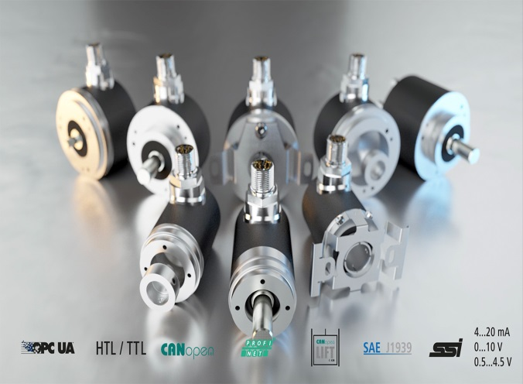

The multi-purpose encoder family in 58 and 36 mm size includes a huge variety of product variants in mechanical design, connection technology and interface connectivity offering users maximum flexibility in choosing the matching sensor. Thanks to their compact size, MAGRES encoders fit into tightest spots. EAM580 with PROFINET supporting the latest communication standards and OPC UA is ideally prepared to make IoT a reality.

For ultimate reliability, the encoder-integrated firmware was designed to comply with EN13849 requirements. In favor of this, functional safety systems up to PLd level are allowed to integrate the encoders as standard components. The encoders are available with redundant sensing and output two position values via CANopen for plausibility evaluation in the master controller.
Integer part of the new robust magnetic encoder generation is the R series with EAM580R and EAM360R. The E1-compliant design for high electromagnetic compatibility, with IP 67 protection and C5-M corrosion resistance is uncompromising durable in demanding outdoor use, for example in mobile automation. In addition, their 0.5 mm² wire core cross-section is fully compatible to automotive connection technology.

Further information: www.baumer.com

Photo:Outstandingly robust magnetic absolute encoders of the MAGRES series by sensor expert Baumer ensure absolute reliability and precise positioning

Number of characters (with spaces): 1684
Text and picture download at: www.baumer.com/press

Baumer Group
The Baumer Group is one of the worldwide leading manufacturers of sensors, encoders, measuring instruments and components for automated image-processing. Baumer combines innovative technologies and customer-oriented service into intelligent solutions for factory and process automation and offers an unrivalled wide technology and product portfolio. With around 2,400 employees and 38 subsidiaries in 19 countries, the family-owned group of companies is always close to the customer. Baumer provides clients in most diverse industries with vital benefits and measurable added value by worldwide consistent high quality standards and outstanding innovative potential. Learn more at www.baumer.com on the internet.

Press contact:  Petra Reichle  Marketing Communications Manager  Phone + 49 7720 942 264  Fax + 49 7720 942 955  preichle@baumer.com  www.baumer.com | Company contact global:  Baumer Group  Phone +41 (0)52 728 11 22  Fax +41 (0)52 728 11 44  sales@baumer.com  www.baumer.com

