Press Release
Robust cable transducers – linear position sensing made easy

(06.06.2016) Sensor expert Baumer is further expanding their portfolio of cable transducers being the easiest, most reliable and cost-efficient way to measure linear motion within a path from 0.5 to 50 m. New series GCA5 is practice-proven when the going gets tough, for example at mobile machinery, and is ideally suited for use in cramped installation conditions.

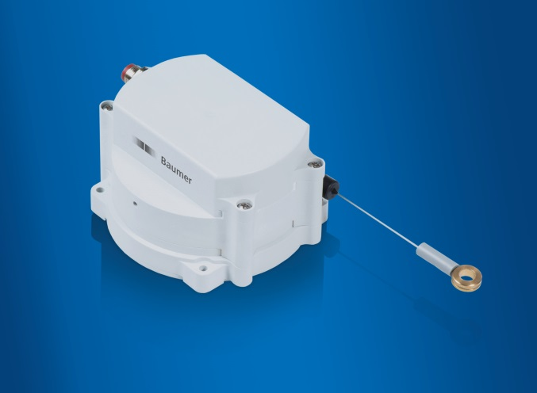

The compact cable transducers of the GCA5 series do not compromise on maximum robustness in demanding applications. The housing of impact-resistant plastics, the corrosion-proof stainless steel cable with abrasion-resistant nylon sheath and the non-contact wear-free magnetic sensing make them the optimal choice for reliable and low-maintenance deployment in harsh environments. Thanks to the innovative design with three-chamber-principle, both electronics and stainless steel spring are hermetically encapsulated against the cable drum. The integrated flexible dirt skimmer at the cable inlet is an additional protection against humidity and ingress of any other harmful environmental substance for maximum application reliability.

The cable transducers of the GCA5 series feature a maximum measuring range of 4700 mm and are available either with integrated CANopen interface or analog output 0.5…4.5 VDC. The CANopen variant provides additionally redundant position sensing and hence simplifies function monitoring at control level. Housing protection IP 67 (cable inlet IP 54), shock resistant up to 50 g, vibration proof up to 10 g and the extended temperature range from -40 to +85 °C make the cable transducers particularly robust and resistant against temperature fluctuations and all kinds of soiling.

The cable transducers of the GCA5 series excel by their narrow design and shallow installation depth of a mere 65 mm which allows easy installation even in cramped space – as prevailing in mobile machinery and utility or transport vehicles. Cable transducers series have been standing the test of time in outrigger positioning at mobile cranes and telehandlers as well as height positioning at floor conveyor trucks and stacker cranes. Whether as OEM equipment or for retrofit – the robust and compact cable transducers are ideal for precise measurement of linear motion in demanding applications.
Further information: www.baumer.com

Illustration: The robust cable transducers GCA5 are ideally suited for outdoor applications and cramped installation space.

Number of characters (with spaces): 2263
Text and picture download at: www.baumer.com/press

Baumer Group
The Baumer Group is one of the worldwide leading manufacturers of sensors, encoders, measuring instruments and components for automated image-processing. Baumer combines innovative technologies and customer-oriented service into intelligent solutions for factory and process automation and offers an unrivalled wide technology and product portfolio. With around 2,300 employees and 38 subsidiaries in 19 countries, the family-owned group of companies is always close to the customer. Baumer provides clients in most diverse industries with vital benefits and measurable added value by worldwide consistent high quality standards and outstanding innovative potential. Learn more at www.baumer.com on the internet.

Press contact:  Petra Reichle  Marketing Communications Manager  Phone + 49 7720 942 264  Fax + 49 7720 942 955  preichle@baumer.com  www.baumer.com | Company contact global:  Baumer Group  Phone +41 (0)52 728 11 22  Fax +41 (0)52 728 11 44  sales@baumer.com  www.baumer.com

