Press Release
SPS: Sustainable automation – shaping a better future together, both economically and ecologically
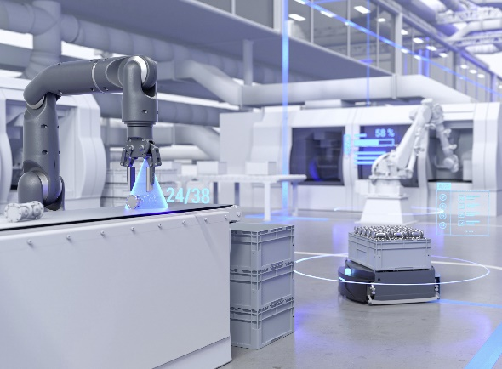
(4 November 2022) At the SPS, the sensor specialist Baumer will show its latest innovations under the banner "Sustainable automation – shaping a better future together, both economically and ecologically". Since the last SPS, Baumer has expanded its Sensor Solution Toolbox with many smart products. "We have set off a firework of innovations. At SPS, we will show new, intelligent solutions for every segment in factory and process automation with great customer benefits over the entire equipment life cycle," promises Baumer CEO Dr Oliver Vietze.
Positioning, detection and identification: For assembly & handling applications, Baumer has expanded its portfolio of optical sensors after the successful market launch of the high-performance miniature photoelectric sensors and photoelectric proximity switches O200. The new ToF sensors OT300 and OT500 reliably detect objects at distances of up to 2.6 m, even with difficult surfaces and independent of the mounting angle. Thanks to their compact design, 3D CAD data with integrated beam path and IO-Link interface, the new smart ToF sensors are also easy to integrate and parameterise. New, high-performance ultrasonic and inductive sensors expand the Baumer Sensor Solution Toolbox for assembly & handling.
Monitor fluid processes: The compact "bubble sensor" PAD20 is a world first. It detects even the smallest air and gas bubbles in liquid media and signals when the individually adjustable limit values for gas inclusions are exceeded. In this way, it protects pumps from running dry. The new CombiLevel PLP70 sets the standard for continuous floatless level measurement. The potentiometric sensor automatically adapts to many media – even process water – and, thanks to its large touch display, enables particularly user-friendly operation and visualisation of the measurement information.
Measure, test and inspect: Baumer also offers a comprehensive sensor portfolio for quality inspection. Trade fair highlights this year are the new precision laser distance sensors of the OM20 and OM30 series as well as the expansion of the unique profile sensors of the OX series. These new products achieve measurement accuracies of 1 micrometre.
Measure speed and angular position: The highlight of the broad Baumer encoder portfolio is the next generation of bearingless encoders, the EB200 series. With its extremely compact design, high resolution, IO-Link and many smart functions, the EB200 series can be easily parameterised for the respective application (speed measurement, speed monitoring, angular position, etc.). The EB200 series complements the uniquely wide product range of industrial encoders, heavy duty encoders and encoders for outdoor applications.
Connect, network and evaluate: The key to the smart factory is networking devices. Smart production starts with the sensor. Baumer offers one of the most comprehensive sensor portfolios with IO-Link. The award winning Baumer Sensor Suite software is the smart solution to fully exploit the potential of IO-Link devices: test, parameterise, analyse – fast, free of charge and even manufacturer-independent.
Sustainable automation – economical and ecological
Baumer understands "sustainable automation" to mean not only developing reliable and high-performance sensors for trouble-free, resource-saving 24/7 operation. "For us, sustainability also means being a long-term partner for our existing and new customers. A partner that you can always rely on to develop new technological solutions. Together with our clients, we create added value, even in difficult times," says CEO Dr Oliver Vietze.
Further information: https://www.baumer.com/in/en/l/bringing-automation-to-life
Baumer at SPS: Hall 4A, Booth 345

Image: Sustainable automation: Since the last SPS, Baumer has expanded its Sensor Solution Toolbox with many smart products for resource-saving production. Image: Baumer

Number of characters (with spaces): approx. 3600
Text and image download: www.baumer.com/press

Baumer Group
The Baumer Group is one of the worldwide leading manufacturers of sensors, rotary encoders, measuring instruments, and components for automated image processing. Baumer combines innovative technologies and customer-oriented service into intelligent solutions for factory and process automation to offer an unrivalled wide technology and product portfolio. With around 2,900 employees and 39 branches in 19 countries, the family-owned company is always close to the customer. Baumer provides clients in the most diverse industries with vital benefits and measurable added value by worldwide consistently high quality standards and outstanding innovation potential. For more information, visit www.baumer.com.

Press contact:  Holger Thissen  Public Relations Manager  Baumer Group  Phone +41 (0)52 728 17 12  hthissen@baumer.com  www.baumer.com | Business contact Germany/Austria:  Baumer GmbH  Phone +49 (0)6031 60 07 0  Fax +49 (0)6031 60 07 60 70  sales.de@baumer.com  www.baumer.com | Business contact Switzerland:  Baumer Electric AG  Phone +41 (0)52 728 11 22  Fax +41 (0)52 728 11 44  sales.ch@baumer.com www.baumer.com

