Press Release
Smart encoder for cost-efficient connection
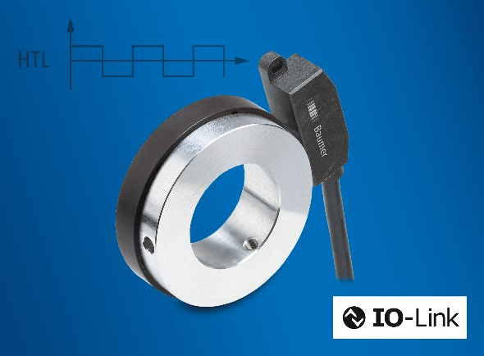
Electrical and mechanical integration of encoders has become much easier and more economically viable. The bearingless encoder EB200E from Baumer, presented at SPS in Nuremberg (November 8-10), is proving this right. It can be compactly integrated on any axis without complex adaptation of the mechanics. EB200E is the first smart incremental bearingless encoder with IO-Link on the market. The interface reduces the cost and effort of cabling and a speed monitoring function replaces additional hardware components.
The IO-Link interface allows for up to 8 encoders to be connected to an IO-Link master by cost-effective standard cables. This way, EB200E opens up completely new areas of application: Encoder parameterization is via IO-Link. This interface enables parameterization of two switching outputs to act as a speed monitor for overspeed, speed range, standstill or direction of rotation. Furthermore, EB200E also delivers conventional HTL signals.
With a shallow installation depth of 12 mm and flexible shaft diameters, the bearingless encoder integrates into the machine design in a space-saving way. Thanks to non-contact sensing between sensor head and magnet ring, the encoder endures dirt, shock or vibration. Also the new Baumer Sensor Suite supports plant engineers as convenient PC tool for intuitive parameterization and data visualization.
Learn more: www.baumer.com/eb200e
Baumer at SPS: Hall 4A, Booth 345

Photo: EB200E smart encoder allows for more efficient machine concepts based on cost-effective connection and parameterization flexibility.

Number of characters (with spaces): approx. 1400
Text and picture download at: www.baumer.com/press

Baumer Group
The Baumer Group is one of the world's leading experts for high-performant sensors and sensor technology in industrial automation. The unrivalled broad product portfolio, precise measured values, and smart sensor functionalities provide intelligent solutions for digitalized production. With around 2,900 employees and 39 of its own development centers, production sites, and sales units in 19 countries, the Swiss family-owned Group is always close to the customers. As an innovation leader for 70 years, Baumer has been creating decisive market advantages and measurable added value with consistently high quality standards. Further information: www.baumer.com

Press contact:  Holger Thissen  Public Relations Manager  Baumer Group  Phone +41 (0)52 728 17 12  hthissen@baumer.com  www.baumer.com | Business contact Germany/Austria:  Baumer GmbH  Phone +49 (0)6031 60 07 0  Fax +49 (0)6031 60 07 60 70  sales.de@baumer.com  www.baumer.com | Business contact Switzerland:  Baumer Electric AG  Phone +41 (0)52 728 11 22  Fax +41 (0)52 728 11 44  sales.ch@baumer.com www.baumer.com

