Press Release

Easier than ever before: VeriSens vision sensors control Universal Robots
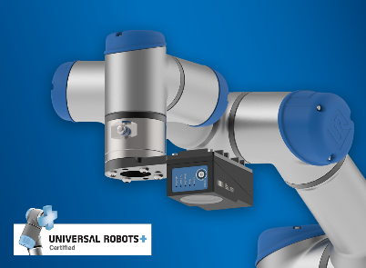
(11/25/2019) The new smart VeriSens vision sensors XF900 and XC900 control the collaborating robots (cobots) of Universal Robots within only a few minutes of setting up. The robot-compatible vision sensors are mounted directly on the cobot or above it. Thanks to the SmartGrid (patent pending), calibration in terms of image distortion, conversion into world coordinates, and coordinate alignment between the vision sensor and robot take place automatically and extremely easy. This eliminates the conventional required elaborate manual “hand-eye” calibration of the robot and vision sensor. This is not only more precise but also reduces the set up to a few minutes. The robot-compatible XF/XC900 models will be available from December 2019.
The installation and configuration of the vision sensors are transparent and easy to understand – via the specifically developed VeriSens URCap interface for robot control, only a few steps are needed to benefit from the diverse VeriSens image processing options. In the programming of the robot itself, only two additional commands (nodes) are necessary to allow a great number of applications across various industries to benefit from the advantages of Vision Guided Robotics. Instead of taught-in waypoints, free positions are used on which objects are then recognized visually. In addition, the already established functions can check object overlaps and gripper clearance. In addition, VeriSens vision sensors can, for example, verify free storage area, carry out quality controls of objects variably positioned in the provided space, as well as identify and measure objects.
More information at: www.baumer.com/verisens-ur
Baumer at SPS: Hall 4A, Booth 335
Photo: The new smart VeriSens vision sensors XF900 and XC900 control the collaborating robots (cobots) of Universal Robots within only a few minutes of setting up.

Number of characters (with spaces): approx. 1800
Text and picture download at: www.baumer.com/press

Baumer Group
The Baumer Group is one of the worldwide leading manufacturers of sensors, encoders, measuring instruments and components for automated image processing. Baumer combines innovative technologies and customer-oriented service into intelligent solutions for factory and process automation and offers an unrivalled wide technology and product portfolio. With around 2,700 employees and 39 subsidiaries in 19 countries, the family-owned group of companies is always close to the customer. Baumer provides clients in most diverse industries with vital benefits and measurable added value by worldwide consistent high quality standards and outstanding innovative potential. Learn more at www.baumer.com on the internet.

Press contact:  Nicole Marofsky  Marketing Communication  Vision Competence Center  Phone +49 (0)3528 43 86 19  Fax +49 (0)3528 43 86 86  nmarofsky@baumer.com  www.baumer.com | Company contact global:  Baumer Group  Phone +41 (0)52 728 11 22  Fax +41 (0)52 728 11 44  sales@baumer.com  www.baumer.com

