Press Release

One sensor, four encoders: New multi-unit axle encoder
BPIV2 by Baumer for the railway industry
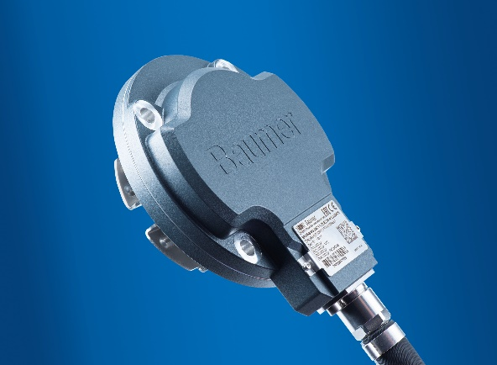
(18.11.2019) They deliver speed information to the driver's cab, regulate traction during start or make sure the wheels do not block when braking: For many train subsystems, precise wheel speed information is indispensable. Operating independently from each other, each subsystem requires an axle encoder of its own. New BPIV2 by Baumer is a self-supported multi-unit axle encoder. Succeeding the very successful BPIV and BMIV encoders, BPIV2 hosts four independent encoders and each can be separately configured. No competitive product on the market provides this benefit. The axle encoder is quickly and safely installed. There is no need for axle-specific adjustments thanks to one-cable overall signal transmission, which considerably cuts down on installation effort.
“Depending on operating conditions, costs in the BPIV2 life cycle are significantly lower than those of conventional axle encoders, " underlines Manuel Niedermann, Product Manager at the Swiss sensor expert Baumer. The exchangeable bearing pack, a Baumer innovation, makes a valuable contribution to reduced life cycle costs. Railway vehicles are expected to be in operation for 30 years and more. Due to tremendous strain in operation, moving parts and especially bearings suffer extreme wear. Up to now, standard procedure was uninstalling the encoder for return to the manufacturer for maintenance. Besides being very time-consuming, it often took several weeks until having the encoder back. With BPIV2 it is completely different: On-site maintenance by replacing the worn bearing pack within half an hour, without requiring any re-adjustments.
But there are more sophisticated features. Taking into account the individual subsystem requirements, the operator can select between units with incremental current or voltage signals to be freely combined within the axle encoder. Each unit allows for free selection of to 1200 ppr to ensure precise speed measurements both at high and low speed. Furthermore, smart BPIV2 features additional functions such as function signal checks to identify any defects - such as a line break - even when the train is at standstill.
Like every other product that is new in the Baumer railway portfolio, BPIV2 come with GS1 compliant labels stating GTIN (article number) and GIAI (serial number). This way, they ensure error-free and efficient identification throughout the entire product life cycle: from shipping to installation on to maintenance.
Much is new with BPIV2, but reputed robustness has remained. Baumer has decades of sensor experience in the railway industry. The independent family-owned Swiss Group is a global leader in the development and manufacture of sensors and encoders and renowned for innovative, tailored solutions even in challenging applications. Baumer played a major role in the development of robust magnetic sensing technology featured by BPIV2. The axle encoders thus defy rough conditions present at the wheel axle, passing compliance tests to EN 50155 with ease. Thanks to the many configuration options, the BPIV2 encoders are the optimum and perfect fit solution for most varied applications on wheel axles.
New BPIV2 axle encoder further adds to the comprehensive Baumer railway portfolio including bearingless, wear-free high-performance axle encoder BPIK as well as sensors for level, pressure and temperature measurement and cameras for inspection systems.
Learn more:
www.baumer.com/ch/de/losungen/bahnindustrie/a/railway

Photo: Multi-unit axle encoder BPIV2 by Baumer allows for easy installation adjustment effort. The exchangeable bearing pack enables field maintenance and is the optimum solution for vehicles with limited shaft ends available.

Number of characters (with spaces): approx. 3394
Text and picture download at: www.baumer.com/press

Baumer Group
The Baumer Group is one of the worldwide leading manufacturers of sensors, encoders, measuring instruments and components for automated image processing. Baumer combines innovative technologies and customer-oriented service into intelligent solutions for factory and process automation and offers an unrivalled wide technology and product portfolio. With around 2,700 employees and 39 subsidiaries in 19 countries, the family-owned group of companies is always close to the customer. Baumer provides clients in most diverse industries with vital benefits and measurable added value by worldwide consistent high quality standards and outstanding innovative potential. Learn more at www.baumer.com on the internet.

Press contact:  Petra Reichle  Baumer Group  Phone +49 7720 942 264  Fax +49 (0)7720 942 955  preichle@baumer.com  www.baumer.com | Company contact global:  Baumer Group  Phone +41 (0)52 728 11 22  Fax +41 (0)52 728 11 44  sales@baumer.com  www.baumer.com

