Press Release

Quality all along the line
OM70 laser distance sensors with line beam shape ensure reliable and precise inline measurements even on structured surfaces

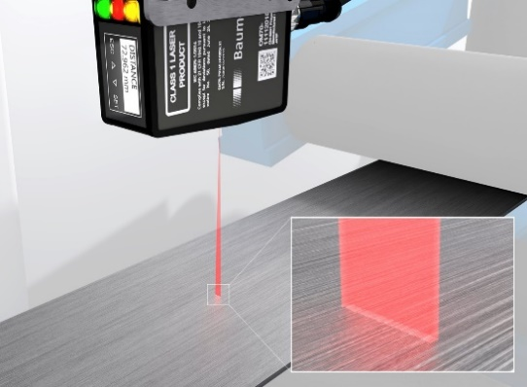
(21.08.2019) Precise, non-contact inline-measurements by optical distance sensors without process interruptions are vital in high-quality product manufacture. In measurements on demanding surfaces such as galvanized or brushed metal, the OM70 laser distance sensors with line beam shape ensure the required reliability. On structured surfaces or colored edges, point laser measurements cause interference and deliver rather inconsistent and little reliable results. Particularly in the measuring focus, the OM70 laser distance sensors feature a very thin beam shape allowing the sensor's receiving array to exploit the full information content. In this way, measuring impairments by minor irregularities such as machining marks, tiny scratches or dents are minimized.
Some application examples for the OM70 laser distance sensors with line beam shape are height measurements towards brushed metal sheets (double sheet detection) or wooden surfaces. Six different measuring ranges from 30 to 1500 mm make OM70 the sensor to choose for most varied applications. For "quality all along the line", the OM70 high performance distance sensors with line beam shape deliver precise and reproducible inline measurement results towards non-homogenous surfaces and cut down on reject rates and costs.
More information available at www.baumer.com/om70

Photo: The fine laser line of OM70 high performance distance sensors ensures consistent and reliable measuring results on non-homogenous metal surfaces

Total characters (with spaces) approx. 1.440
Text with illustration available for download at: www.baumer.com/press
Baumer Group
The Baumer Group is one of the worldwide leading manufacturers of sensors, encoders, measuring instruments and components for automated image processing. Baumer combines innovative technologies and customer-oriented service into intelligent solutions for factory and process automation and offers an unrivalled wide technology and product portfolio. With around 2,700 employees and 38 subsidiaries in 19 countries, the family-owned group of companies is always close to the customer. Baumer provides clients in most diverse industries with vital benefits and measurable added value by worldwide consistent high quality standards and outstanding innovative potential. Learn more at www.baumer.com on the internet.

Press contact:  Andrea Memminger-Wäsch  Baumer Group  Phone +41 (0)52 728 11 22  Fax +41 (0)52 728 11 44  amemminger-waesch@baumer.com  www.baumer.com | Company contact global:  Baumer Group  Phone +41 (0)52 728 11 22  Fax +41 (0)52 728 11 44  sales@baumer.com  www.baumer.com

